**IPMC TRAINING COLLEGE, KUMASI.**

**SOFTWARE ENGINEERING 11AM-1PM**



**PROJECT TITLE: ONLINE STUDENT CLEARANCE SYSTEM**

**STUDENT’S NAME**:

OWUSU-ACHEAW ANGELO

**PROJECT SUPERVISOR:**

MR. AGYEI EMMAUEL

**SEPTEMBER 2020**

# 

# DECLARATION

I declare without any reservation that I personally undertook this project, “Online Student Clearance System” on IPMC campus, herein submitted under supervision.

**ACKNOWLEDGEMENTS**

I take this occasion to thank God, almighty for blessing us with his grace and taking our endeavor to a successful culmination. I extend my sincere and heartfelt thanks to my esteemed supervisor, Mr. Agyei Emmanuel for providing me with the right guidance and advice at the crucial junctures and for showing me the right way. Last but not the least, I would like to thank friends for the support and encouragement they have given me during the course of the work.

**Table of Contents**

DECLARATION…………………………………………………………………………………2

ACKNOWLEDGEMENTS………………………………………………………………………3

ABSTRACT………………………………………………………………………………………6

**CHAPTER 1**

* 1. INTRODUCTION…………………………………………………………………………….7
  2. PROBLEM DEFINITION…………………………………………………………………….8
  3. OBJECTIVES OF THE STUDY……………………………………………………………...8
  4. SIGNIFICANCE OF THE STUDY…………………………………………………………...9
  5. SCOPE OF THE STUDY……………………………………………………………………...9
  6. LIMITATIONS………………………………………………………………………………10
  7. DEFINITION OF TERMS…………………………………………………………………...11

**CHAPTER 2**

**LITERATURE REVIEW**

2.1 INTRODUCTION……………………………………………………………………………12

2.2 RELATED WORKS…………………………………………………………………………12

2.3 PROBLEM OF THE CURRENT SYSTEM…………………………………………………15

2.4 JUSTIFICATION FOR THE NEW SYSTEM……………………………………………….15

**CHAPTER 3**

**SYSTEM DESIGN METHODOLOGY**

3.1 INTRODUCTION……………………………………………………………………………16

3.2 METHODOLOGY…………………………………………………………………………...16

3.3 OUTPUT SPECIFICATION AND DESIGN………………………………………………..20

3.4 INPUT SPECIFICATION AND DESIGN…………………………………………………..20

**CHAPTER 4**

**TESTING AND IMPLEMENTATION**

4.1 INTRODUCTION………………………………………………………………………….22

4.1.1 UNIT TESTING………………………………………………………………………….23

4.1.2 SYSTEM TESTING……………………………………………………………………...23

4.1.3 USABILITY TESTING…………………………………………………………………..23

4.2 IMPLEMENTATION………………………………………………………………………27

4.3 USER TRAINING………………………………………………………………………….28

4.4 SECURITY AND MAINTENANCE………………………………………………………28

4.5 SYSTEM REQUIREMENTS……………………………………………………………….29

4.5.1 HARDWARE REQUIREMENTS………………………………………………………..29

4.5.2 SOFTWRE REQUIREMENTS…………………………………………………………..29

4.5.3 OPERATIONAL REQUIREMENT……………………………………………………...30

4.5.4 PERSONNEL REQUIREMENT…………………………………………………………30

**CHAPTER 5**

**CONCLUSION AND RECOMMENDATION**

5.1 CONCLUSION…………………………………………………………………………….31

5.2 RECOMMENDATION……………………………………………………………………31

5.2.1 ENHANCEMENT……………………………………………………………………….32

**REFERENCES**…………………………………………………………………………………33

Figure 1………………………… Flowchart of Online Clearance System

Figure 2…………………………System Activity – Use Case Diagram

Figure 3…………………………..Welcome Screen

Figure 4………………………….Login Modal

Figure 5…………………………Admin Dashboard (Available Clearances)

Figure 6………………………….Admin Set Clearance Deadline

Figure 7………………………….Staff Dashboard (Accountant)

Figure 8…………………………..Staff Dashboard (Requirements page)

Figure 9…………………………Student Dashboard (Clearance Status)

Figure 10…………………………Student Password Reset

Figure 11…………………………Staff Create Notification

**ABSTRACT**

Online Student Clearance System is a research work that will help build an effective information management for schools. It is aimed at developing a system for making clearance after graduation hitch free. The designed system will serve as a more reliable and effective means of undertaking students’ clearance, remove all forms of delay and stress as well as enable you understand the procedures involved as well as how to do your clearance online.

In this project, the implementation of the computer-based system was carried out using PHP, CSS, APACHE and MYSQL for the database. In conclusion, the work met all the objectives intended. It is, however, recommended for use by all tertiary institutions.

**CHAPTER ONE**

* 1. **INTRODUCTION**

Clearance is a status granted individuals, typically members of the military, university graduates and employees of governments and their contractors, allowing them access to classified information. The term “clearance” is also sometimes used in private organizations that have formal process to vet employees for access to sensitive information. A clearance by itself is normally not sufficient to gain access; the organization must determine that the cleared individual has a “need to know” the information.

As many universities have chosen to pursue the dynamic educational options available online. The advantages of e-learning are many. As people of all ages and backgrounds become increasingly reliant on the internet for information, online learning becomes more convenient and efficient here the need for an online clearance system. The skills needed to access and comprehend information online are becoming commonplace, and the flexibility of wireless computing means that any coffee shop, airport or bedroom can become a classroom. Online courses, registrations, clearance have few, if any scheduling restrictions, well-integrated learning resources and competitive degree options, with an online clearance system.

The changing online college landscape now includes online clearance system, traditional undergraduate and general studies programs. However, career learning is still the most popular online training option.

* 1. **PROBLEM DEFINITION**

The process of clearing students after their graduation requires that the students be cleared in various departments and information units. For a graduating student to carry out his/her clearance from the various departments, it normally takes a lot of time and a lot of processes and delay in clearing the student. There are no proper or effective platforms provided by most universities to store and record the information, and also there are no proper or effective ways to retrieve certain data or information immediately at one place. The system mainly used is the manual or traditional way. Hence, it has become imperative for computer software based online clearance system to eliminate the shortcoming of the manual system in place.

**Scenario:**

Students have difficulties in checking their clearance status. In these days, they need to go to each department and check with the department manually, and sometimes they tend not to get the full information they need. It takes time to complete the clearance form as they need to queue or come again the next day because the universities have lots of students that want to do the clearance every semester.

* 1. **OBJECTIVES OF THE STUDY**

The objectives of the project include:

1. **To automate the manual system.**

Most of the technical work can be automated as long as it has the logic inside. But the concern is when it needs human intervention to make the process more accurate rather than too limited to the current configuration.

1. **To ease the clearance process.**

The student can do the clearance through online rather than going for every department such as finance department to do the clearance. The system should be accessible everywhere.

1. **To migrate from manual to computerized system.**

To reduced paper based work, time constraint, and workload. Therefore, this system will help the staff to make the system clearance more easily and effectively.

* 1. **SIGNIFICANCE OF THE STUDY**

The project will help in a good number of ways to ease the queuing system in the university as the online clearance system will help students to achieve whatever they want to achieve without coming to various offices for clearance.

Clear advantages of internet information processing over those of traditional manual system are higher yields. Online clearance system allows the users to check their clearance status as whether they are in any way indebted to the school, fill and submit their clearance form, and obtain their clearance letter. There are many other advantages of online clearance system and some of them are listed below.

* It saves a lot of time
* It is very convenient to use it right from anywhere you find yourself
* Information processing are very fast and delays can be avoided
* It is inexpensive to students and school management. Help the school in reducing costs such as labour and stationery
  1. **SCOPE OF THE STUDY**

This research work is limited to clearance system for graduating students from the university. The software development will be carried out using PHP, HTML, CSS, JAVASCRIPT and MYSQL to manage both the database and at the same time make the software online.

* 1. **LIMITATIONS**

This project covers all aspect of online clearance system in the university. However, the following were the constraints:

* **Time constraints:** Due to time constraint, the web page developed covers only clearance from various departments by the graduating students.
* **Financial constraints:** It would cost a lot to develop a full web-based clearance system.
  1. **DEFINITION OF TERMS**
* Computer Network: Computer Network is a system that connects two or more computers together using a communication link.
* World Wide Web: World Wide Web simply called www is the most important tool of the internet. It was created in the late 1980s in Europe and was used limitedly in academic cycle.
* Clearance: Official certification of blamelessness, trustworthiness, or suitability for graduation and issue of certificates in degree course.
* Databases: A systematically arranged collection of computer data, structured so that it can be automatically retrieved or manipulated. It is also called databank
* File Transfer: Any kind of computer file can be sent via the internet from one internet user to another.
* Web Browser: The special kind of software that processes hypertext markup language (HTML) document. In other words, a web browser is a computer program that interprets HTML command to collect, arrange and display the parts of a web page.
* Web Site: A website is a collection of many interconnected web pages organized by a specific college, organization, company, etc, containing web pages on the internet. Web sites are stored on web servers. There are many websites and thousands of HTML pages on each website.
* Hyperlinks: Hyperlinks are highlighted words and phrase you find on web documents that you can click on as to jump to some other documents or internet services.
* Online: Connected via a computer attached to or available via a central computer network.
* Offline: Disconnected from a computer network; describes a computer terminal or peripheral device disconnected from a computer network.
* System: set of computer components that is, an assembling of hardware, software and peripherals functioning together.

**CHAPTER 2**

**LITERATURE REVIEW**

**2.1 INTRODUCTION**

The traditional way of clearing students after graduation is the commonest approach used by most educational institutions and training centres. When a student is about to graduate, he/she will take his/her degree exam after which he/she obtains clearance letter from various departments and unions. The registrar’s office carefully reviews each degree candidate’s academic records and certificate to faculty that the candidate has completed his/her requirement for the degree. Also, the bursary has to certify that the student completed all payment.

The current clearance system of most universities is a manual one. This makes it tedious and time consuming. Here, the student has to visit all the clearance offices with a form for them to sign, once this form is signed, it proves that the student has been cleared. The process takes some months to be completed and creates a lot of stress to both staff and student involved. In the manual system, the clearance forms are documented in a file cabinet. Each time the clearance form is needed, a search operation is conducted on the file cabinet to locate a particular student’s clearance form.

**2.2 RELATED WORKS**

Clearance is a certificate giving permission for something to be done. In higher learning institutions, final year students that have satisfied the academic requirements to graduate must undergo a clearance process before they disengage from the institution. The above fact prompted the development of a web-based database-driven students’ clearance system by Abo-Ajala and Makinde (2015). The system was developed using PHP and MySQL, and is aimed at eliminating the delays associated with the manual process of final clearance. In similar manner, Umezinwa, Uwakwe and Abode (2015) developed online clearance for final year clearance of Imo State University using PHP, JAVASCRIPT, CSS, APACHE and MySQL for the database. The above system was able to process data with speed and also replaces the error-prone manual clearance system.

Zuhaib (2013) supervised a project on the development of online clearance system using ASP.Net to create interfaces of the system. The system which is implemented at Quest University, Nawabshah contains database that can store all the required information of students for clearance certificate via web pages. Awuzie (2013) summarizes the advantages of online clearance system to include the following:

1. It saves a lot of time.
2. It is very convenient to use anywhere at any time. E.g. office, bedroom or anywhere in the world.
3. Information processing is very fast and delay can be avoided.
4. It is inexpensive to students and school management.
5. It also helps the school in reducing cost such as labour and stationery.

As many universities have chosen to pursue the dynamic educational options available online, the advantages of e-learning cannot be estimated. According to Cox (2005), online system is presented as an efficient means of conveying instruction to an extensive learning community any place at any time. Indicating that adequate attention be designated to online learning as it serves as the driving force and model for transformation of teaching, learning and formal schooling, Environmental Education and Training Partnership (2006) posits that, online course has the potential to provide learner individualized attention by the instructor. This is otherwise impossible in a large classroom environment.

With the continued development of online system applications, many colleges and universities have begun to offer online courses as an alternative to traditional face-to-face instructions. Hillstock (2005) reports that 67% of colleges and universities agreed that online education are the most logical long-term strategies for their institutions. However, there are considerable hesitations rising predominantly related quality and student respectively to online system, (Yong and Conellus, 2004). Just as their advantages there are also disadvantages to the online system of instruction delivery method. There is evidence through previous research that students feel isolated or disconnected when not engaged in traditional face-to-face instruction (Guhu 2001; Graham, 2001), while other reports indicate large success (Hoffman, 2002; Kaczynski and Kelly, 2004; Meyer, 2006). There remains a lack of clarity whether online courses are as effective as traditional courses (Peirier and Feldman, 2004).

While there has been vast number of studies conducted on the merits and demerits of online system institution, little is known on how assessment is used in online classroom to monitor performance and progress (Liang and Creasy, 2004). Hew, Liu, Martinez, Bonk and Lee (2004) describe the evaluation of current online education system at three levels; the macro level, the meso level and the micro level. The macro level is an online evaluation that access an entire online program, the meso level evaluation access individual online courses, and the micro level access the learning of the online student.

Several communicational tools are at the disposal of students and staffs to support their activities during the clearance. The partner universities offer two virtual communication tools with different capabilities ***“Marratech and Central”.*** It is also available online as the communication management systems (CMS) and independent discussion forum.

Marratech is a virtual interactive tool that allows holding meeting and video conferencing on the web, face-to-face, whenever you want to talk, see each other and share application and document without being in the same room, the same building, or even the same country. This platform is used in several systems, like in the energy online master program for lectures, project meetings and project presentation. Central enables group to work faster and more effectively by automating critical clearance system and training initiatives online through virtual classroom, online meeting and web conferences. Central has a broad array of features that make live, group-oriented system effective on the web. Interactive white board, YES/NO feedback, hand-raising, multi-point conferencing, advanced application sharing and text and fool-duplex chart examples, in energy online master program for lectures, project meetings and project presentation. Communication management tools are available at each university and also in an online clearance system homepage.

**2.3 PROBLEM OF THE CURRENT SYSTEM**

Due to the manual means being used by most universities and colleges, especially in the Intercom Programming and Manufacturing Company (IPMC), a lot of problems are encountered when keeping information about student clearance. Some of them include:

* Delay in processing of the form.
* Unavailability of some key staffs while processing clearance form, which results in students repeatedly visiting a particular office in order to get clearance forms signed.
* Takes a lot of time to retrieve a particular clearance form.
* Damage of documents due to fire or rain incident.
* Loss of vital document as the filing system is manual.
* Illegal removal of forms by fraudulent staff leading to insecurity.

**2.4 JUSTIFICATION FOR THE NEW SYSTEM**

The new system is designed to solve problems affecting the manual system in use. It is designed to be used online thereby both student and staff from much stress as experienced from the manual system.

This will do the analysing and storing of information either automatically or interactively. It will make use of online access to the internet. The proposed system will also have some other features like:

* Fast rate of operation and excellent response time.
* Better storage and faster retrieval system.
* Accessibility from any part of the world.
* Accuracy in handling of data.
* Flexibility (i.e.) it can be accessed at any time
* Easy way of backing up data in case of data loss.

**CHAPTER 3**

**SYSTEM DESIGN METHODOLOGY**

**3.1 INTRODUCTION**

This chapter presents the project methodology, which involves introduction to the topic, the different types of development methodology, their advantages and disadvantages, case study are, development tools and summary of the chapter.

Project Management Methodology is defined as a combination of logically related practices, methods and processes that determine how best to plan, develop, control and deliver a project throughout the continuous implementation process until a successful completion and termination.

Project Management Methodology is a scientifically-proven, systematic and disciplined approach to project design, execution and completion.

**3.2 METHODOLOGY**

The proposed system uses a top-to-down design which is a software design technique which is aimed to described functionality at a very high level, then partition it recursively into more detailed level one at a time as shown in figure 1. The information captured in figure 1 is further described in figure 2, which depicts the Use-Case diagram showing the interaction between the user and the proposed system. In designing the proposed system for managing graduating student clearance system, the following will be used:

* PHP language
* JavaScript
* CSS
* MySQL server as the database.

Login graduating student

Is record found?

No

yes

Make Payment

Show error message

Is payment successful?

No

yes

Fill and submit form for various units

Form submitted successfully?

No

yes

Save to database

Save to database

Send clearance certificate notification to student

Send clearance certificate notification to student

Figure 1: Flowchart of Online Clearance System

There are three models and each model will be a different phase that will be worked on.

* Student Model: The student will logon to the software and fill out the clearance form. The student checks for announcements and clearance summary as well as clearance status after form has been filled. All unsettled payments have to be made before clearances are granted by the staff.
* Staff Model: Staff model comprises the Finance Staff, Dean, Registrar and Library Staff. The staff logon to the system and post announcements to alert students of events. They also grant clearances to students who have no unsettled payments.
* Webmaster Model: The Webmaster posts announcements and updates clearance summary. The webmaster is able to add new staff and also update current staff details. Deadlines for completion and submission of clearance forms are set by the webmaster as well as updates on clearance status.

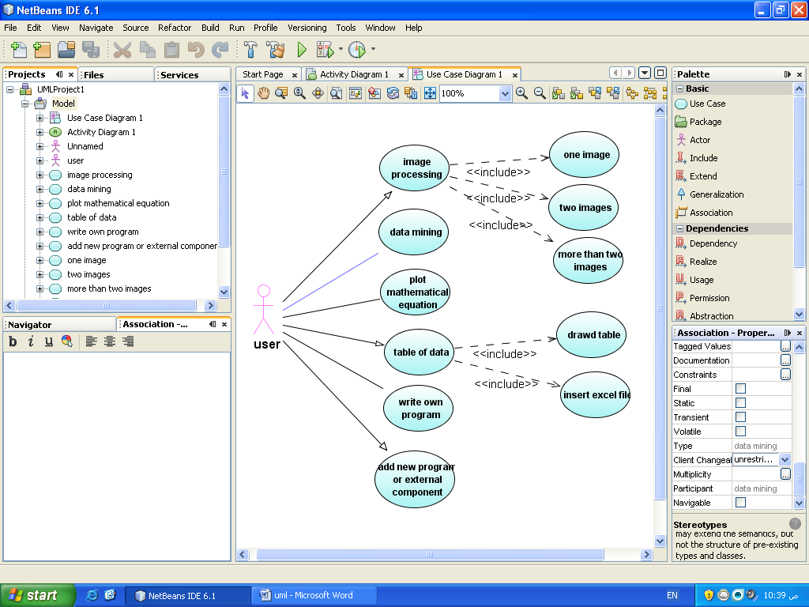F**igure 2: System Activity – Use Case Diagram**

Student Activity

student



Staff Activity

Staff

Webmaster Activity



webmaster

* 1. **OUTPUT SPECIFICATION AND DESIGN**

The sequence of the report is one of the important features that could be concluded. This is emphasized because it forms the basis of the school effective well document up-to-date and formatted output to help as a tool in planning and decision making/based on the student clearance form.

There are methods of generating reports in the new package.

Hardcopy – This is a process of printing from the printer to paper, and

Softcopy – It is the process of displaying an output on the computer screen.

The reports generated by the system include;

* Student clearance status
* Student clearance certificate

**3.4 INPUT SPECIFICATION AND DESIGN**

It is also necessary to denote that data entered in the computer for processing determines what the output will be. Screen designs are generally or basically mad for data entry or capture. Since data are captured from a hardcopy form, the sequence of data capture should be identical to the hardcopy from made for data collection.

The new system is composing mainly of two forms of input, they are:

* Student registration form
* Clearance form

**CHAPTER 4**

**TESTING AND IMPLEMENTATION**

**4.1 INTRODUCTION**

Software testing is a process to evaluate the functionality of a software application with an intent to find whether the developed software met the specified requirements or not and to identify the defects to ensure that the product is defect free in order to produce the quality product. Software testing can also provide a view of the software that allows the user to appreciate and understand the risks of software implementation. Software testing involves the execution of a software component or system component to evaluate one or more properties of interest. In general, these properties indicate the extent to which component or system under test:

* meets the requirements that guided its design and development
* responds correctly to all kinds of inputs
* performs its functions within an acceptable time
* is sufficiently usable
* can be installed and run in its intended environments
* achieves the general results desired of stakeholders.

As the number of possible tests for even a simple software component, is practically infinite, all software testing uses some strategy to select tests that are feasible for the available time and resources. As a result, software testing typically attempts to execute a program or application with the intent of finding software bugs (errors or other defects). The job of testing is an iterative process as when one bug is fixed, it can illuminate other, deeper bugs, or can even create new ones.

Software testing can provide objective, independent information about the quality of software and risk of its failure to users or sponsors.

Software testing can be conducted as soon as executable software (even if partially complete) exists. The overall approach to software development often determines when and how testing is conducted. In the developmental method used in building this online clearance system, most testing occurs concurrently with the development of the system.

Software testing comes in various levels. These levels are Unit Testing, System Testing, Usability Testing.

**4.1.1 UNIT TESTING**

Unit Testing is done to check whether the individual modules of the source code are working properly. i.e. testing each and every unit of the application separately by the developer in the developer’s environment. It is also known as module testing or component testing.

This online clearance system comes in three modules, the student module, staff module, and webmaster module, each of these units have been evaluated on their functionalities, the authorization and authentication of each module and they all satisfy the software requirements set to build this system.

**4.1.2 SYSTEM TESTING**

System Testing is a phase in software testing cycle performed to evaluate the complete system, the system’s compliance against specified requirements. This is a method in which testers evaluate the functionality of the software under test without looking at the internal code structure. In system testing, thorough testing of every input in the application to check for desired outputs.

System testing is usually carried out by a team that is independent of the development team in order to measure the quality of the system unbiased. It includes both functional and non-functional testing.

**4.1.3 USABILITY TESTING**

Usability testing is a technique used in user-centered interaction design to evaluate a product by testing it on users. This can be seen as an irreplaceable usability practice, since it gives direct input on how real users use the system. Usability testing focuses on measuring a human-made product’s capacity to meet its intended purpose.

Also, software testing comes in various kinds i.e. White box testing, Black box testing.

***White box testing***

* **Feature testing**
* To test every function provided in the system
* To check whether the functions follow user and system requirement
* To identify the flaw and suitable corrections for each and every function
* **Integration testing**
* To test the integration of the functions.
* To see whether movements from one function to another is as intended or not.
* To identify necessary corrections to perform on each set of function with flaws or errors.
* **Regression testing**
* To re-check the functions after corrections have been made.
* To see whether corrections that have been met comply with the requirements.

***Black box testing***

* **System testing**
* To test the system as a whole and check each set of function together with their movements to ensure that the system fulfil all requirements.
* To familiarize with the system and see the product of each subset of the system.
* **Load testing**
* To test the capability of the system in receiving and processing a huge and bursting amount of access and data.

**Kind of testing used: White box and Black box.**

**Testers:**

* **Internal testers**
* Internal user 1 acted as student.
* Internal user 2 acted as webmaster.
* **External testers**
* External user 1 acted as Staff (Accountant).
* External user 2 acted as Staff (Dean).

**Testing information:**

* Internal testers and external testers are selected among friends.
* Both testers were given freedom to execute and run any function as desired.
* Each tester must record this information for each test case executed:
* Input entered.
* Output obtained.
* Functions accessed.
* List of functions executed.

**4.2 IMPLEMENTATION**

Implementation is the stage in the project where the theoretical design is turned into a working system and is given confidence on the new system for the users that it will work efficiently and effectively. It involves careful planning, investigation of the current system and its constraints on implementation, design of methods to achieve the changeover, an evaluation of change over methods. Apart from planning major task of preparing the implementation, are education and training of users. The implementation process begins with preparing a plan for the implementation of the system. According to this plan, the activities are to be carried out, discussions made regarding the equipment and resources and additional equipment has to be acquired to implement the new system. In network backup system, no additional resources are needed.

Implementation is the final and most important phase. The most critical stage in achieving a successful new system is giving the users confidence that the new system will work and be effective. The system can be implemented only after thorough testing is done and if it is found to be working according to the specification.

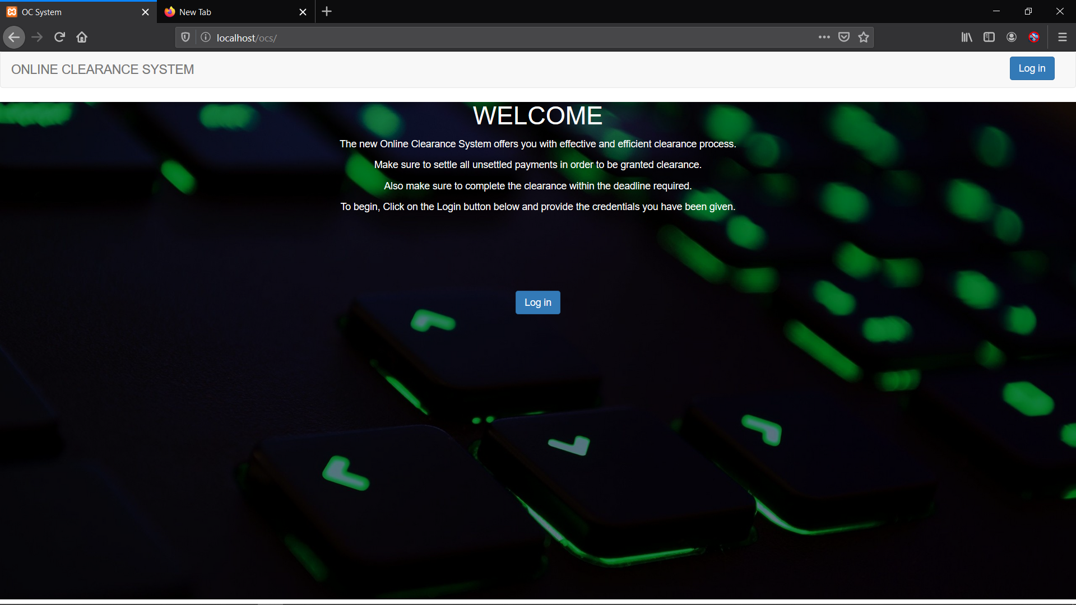

**Figure 3: Welcome Screen**

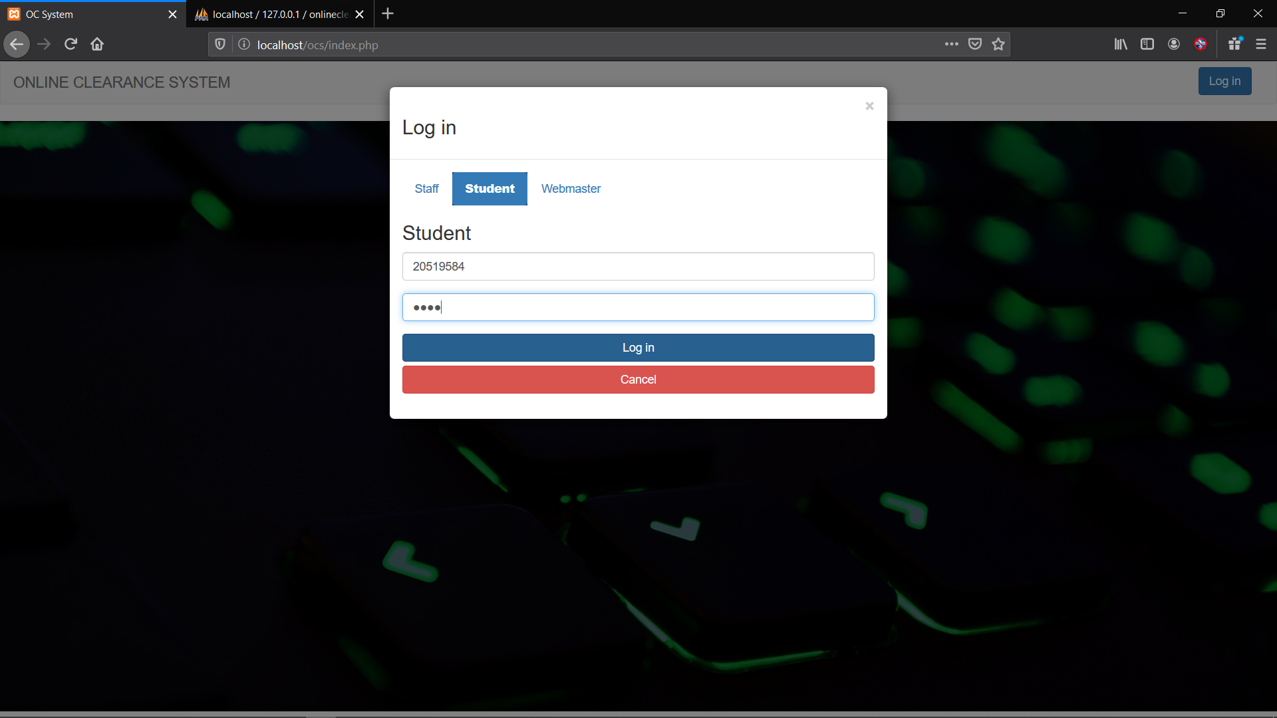

**Figure 4: Login Modal**

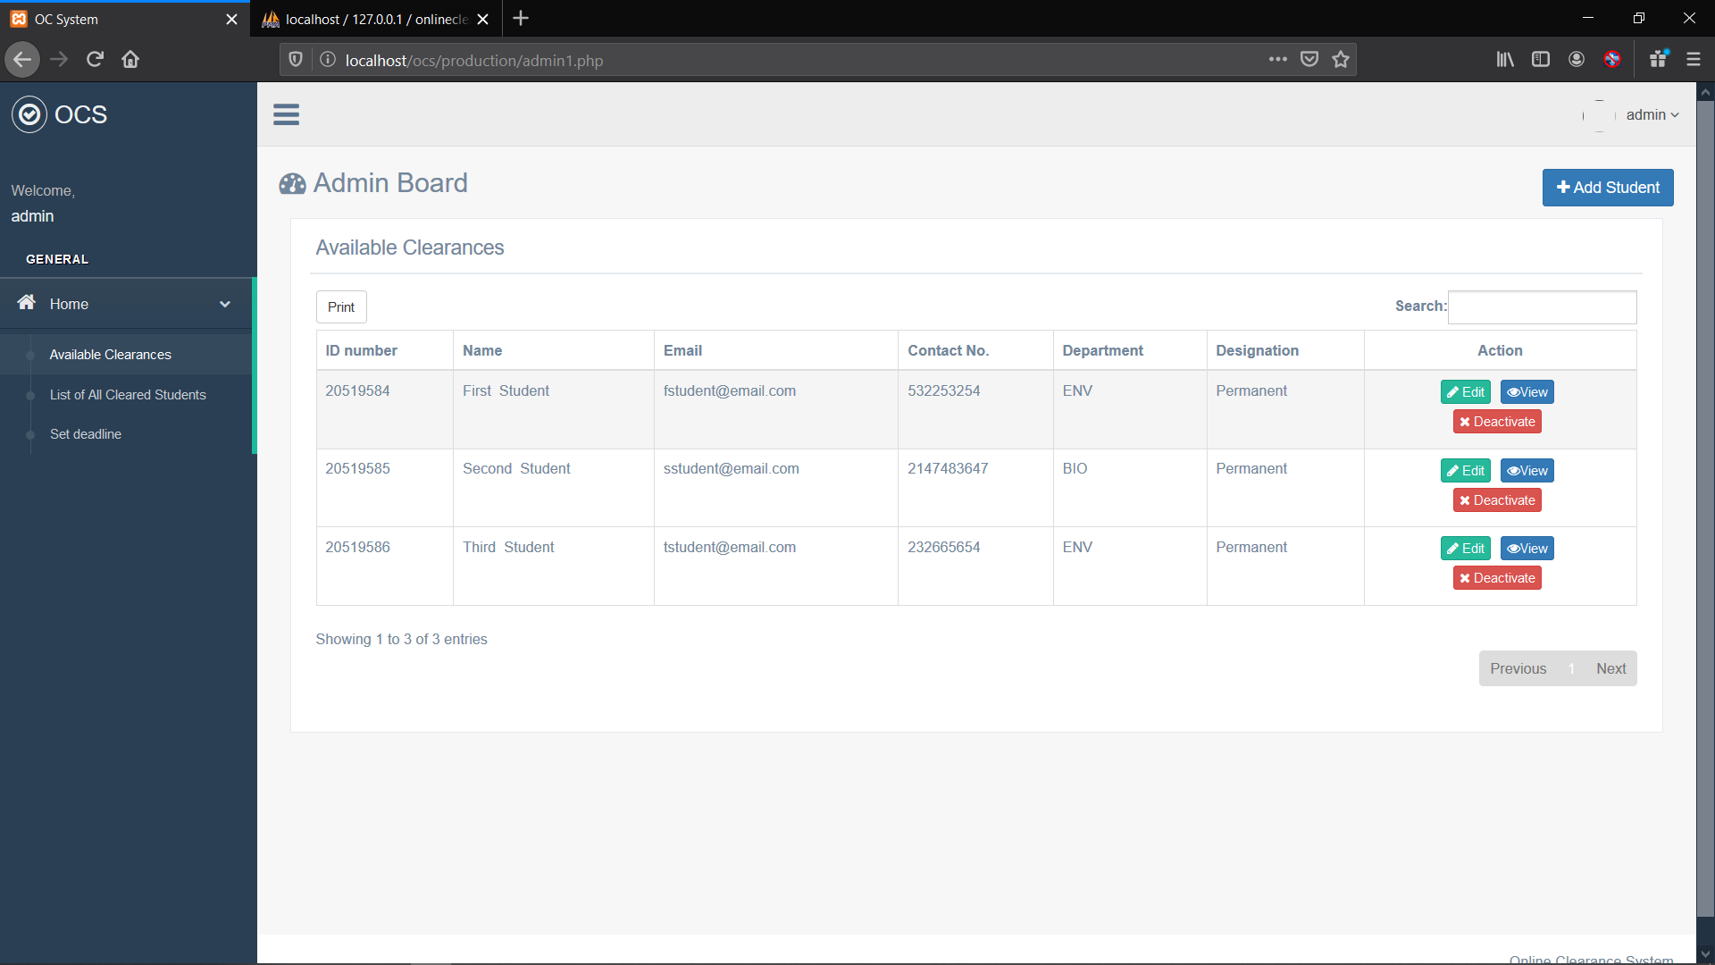

**Figure 6: Admin Board (Available Clearances)**

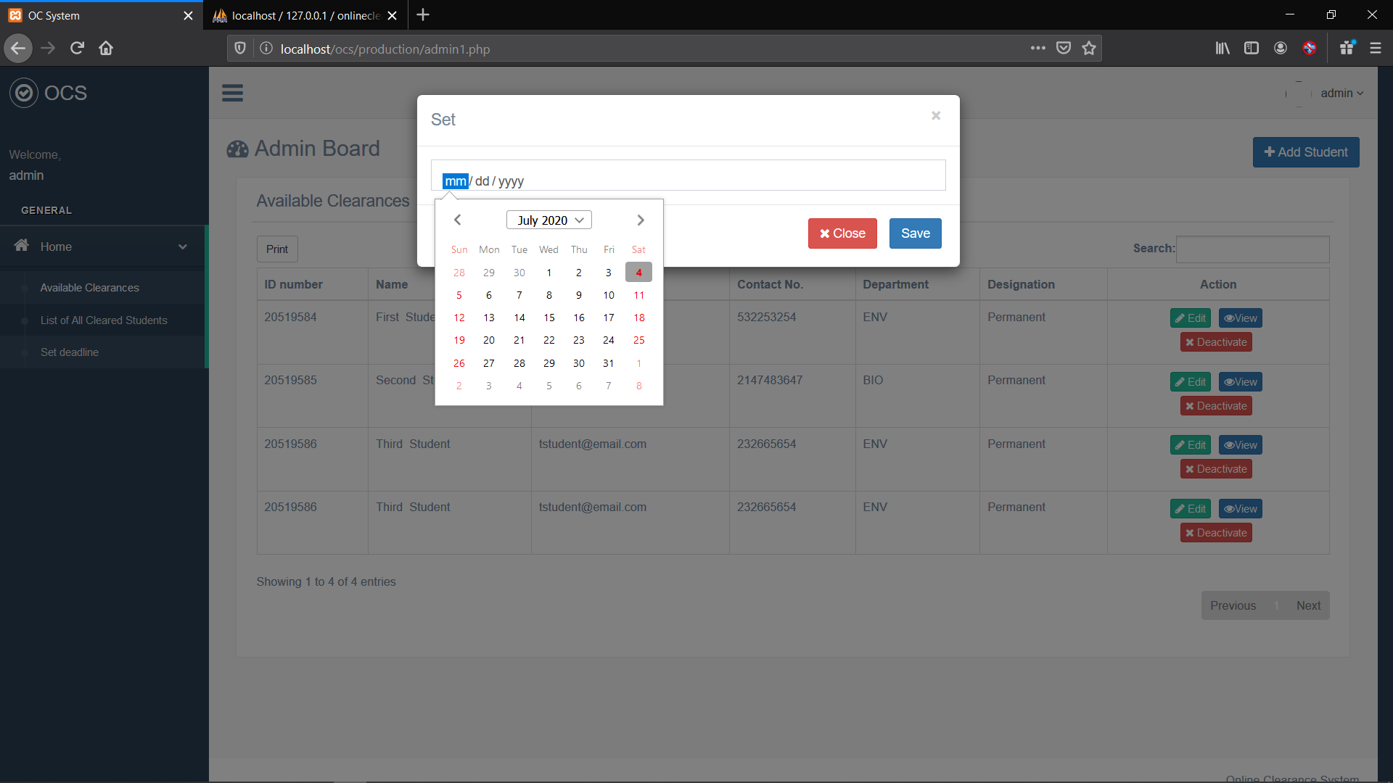

**Figure 7: Admin Set Clearance deadline**

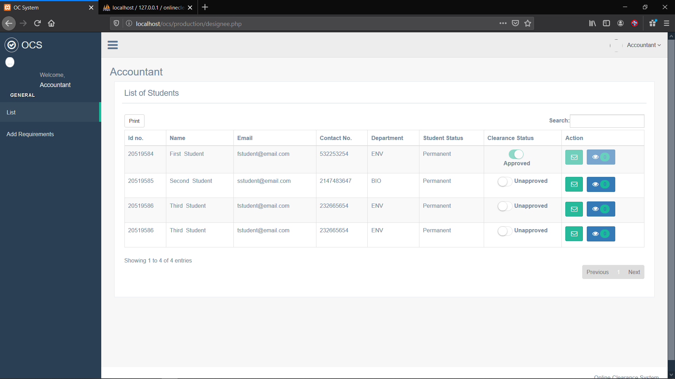

**Figure 8: Staff Board (accountant)**

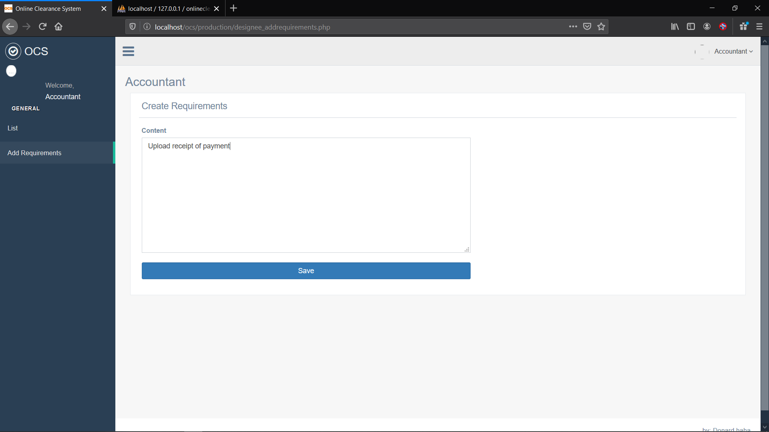

**Figure 9: Staff Board (requirements page)**

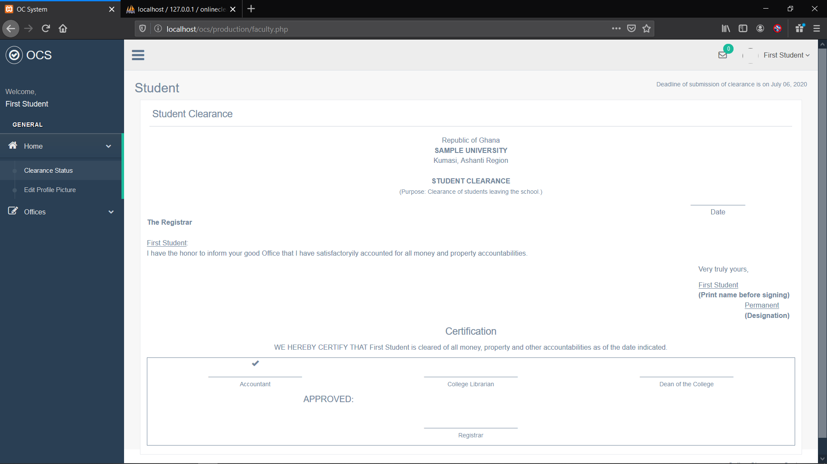

**Figure 10: Student Dashboard (Clearance Status)**

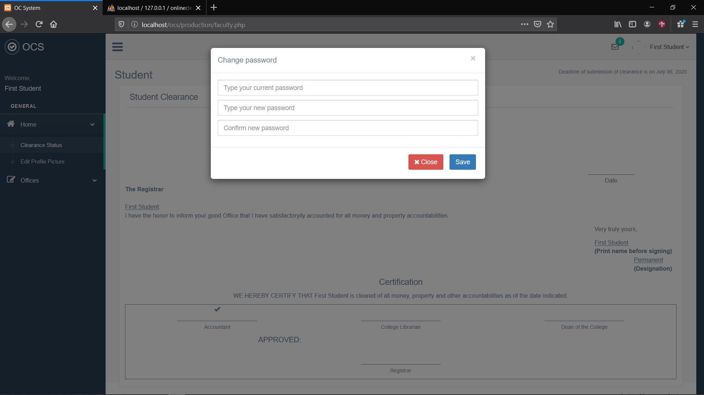

**Figure 11: Student Password Reset**

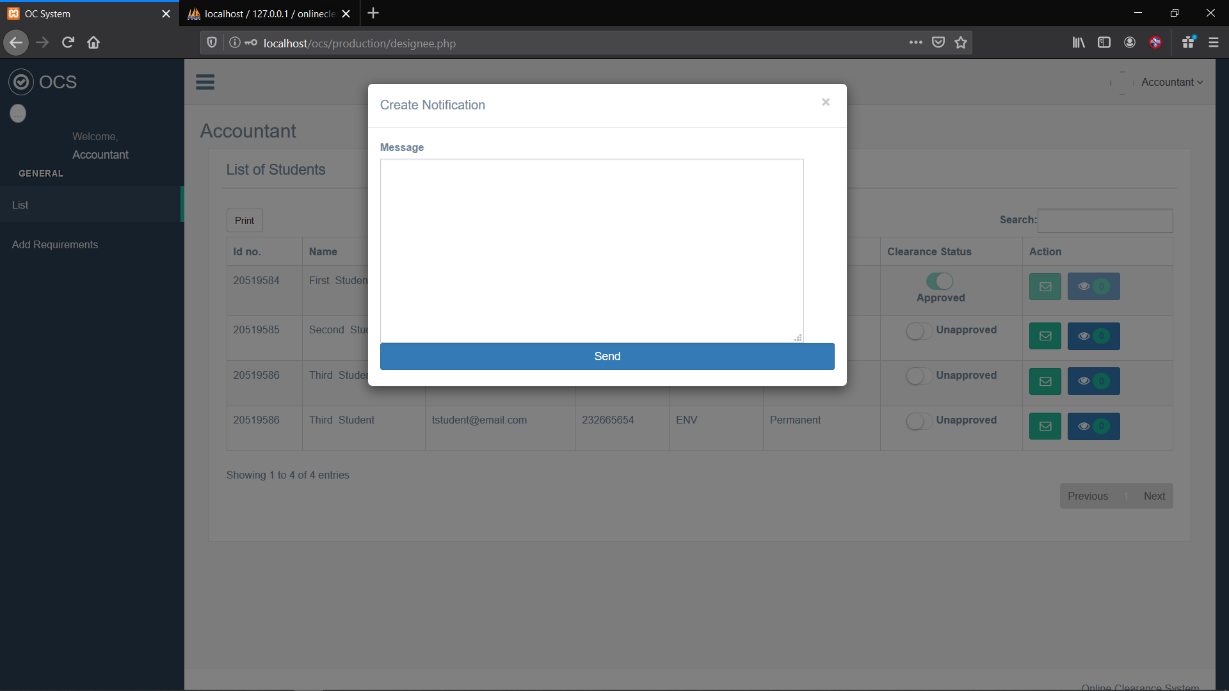

**Figure 12: Staff Create Notification**

**4.3 USER TRAINING**

After the system is implemented successfully, training of the user is one of the most important subtasks of the developer. For this purpose, user manuals are prepared and handed over to the user to operate the developed system. Thus, the users are trained to operate the developed system. Both the hardware and software securities are made to run the developed systems successfully in future. In order to put the new system into use, the following activities were taken care of:

* Preparation of user and system documentation.
* Conducting user training with demo and hands on.
* Test run for some period to ensure smooth switching over the system.

The users are trained to use the newly developed functions. User manuals describing the procedures of using the functions listed on menu are circulated to all the users. It is confirmed that the system is implemented up to users need and expectations.

**4.4 SECURITY AND MAINTENANCE**

Maintenance involves the software industry captive, typing up system resources. It means restoring something to its original condition. Maintenance follows conversion to the extent that changes are necessary to maintain satisfactory operations relative to changes in the user’s environment. Maintenance often includes minor enhancements or corrections to problems that surface in the system’s operation. Maintenance is also done based on fixing the problems reported, changing the interface with other software or hardware enhancing the software.

Any system developed should be secured and protected against possible hazards. Security measures are provided to prevent unauthorized access of database at various levels. An uninterruptible power supply should also be used so that the power failure or voltage fluctuations will not erase the data in the files.

Password protection and simple procedures to prevent the unauthorized access are provided to the users. The system allows the user to enter the system only through proper username and password.

**4.5 SYSTEM REQUIREMENT**

The requirement needed to implement this system is as follows:

**4.5.1 Hardware Requirement**

For the effective operation of the newly designed system, the following minimum hardware specifications are recommended.

1. The computer system in use should IBM compatible since they are considered clone system.
2. The Random Access Memory (RAM) should be at least 128MB.
3. The system should have a hard disk of at least 50GB.
4. The system should be equipped with an E.G.A/V.G. A, a colour monitor.
5. An uninterruptible power supply (UPS) unit.
6. It should be internet ready.

These listed configurations are the minimum requirement but if the configurations are higher, the report derived will definitely be better and the program will run much faster.

**4.5.2 Software Requirement**

The software specification required on the computer is:

* A windows XP or higher version for faster processing
* HTML
* Text Editor
* Dreamweaver 8.0 / XAMPP
* PHP
* MySQL
* Apache Server 2.5
* Fire Works
* Mozilla Web Browser

**4.5.3 Operational Requirement**

For the new system to be operational, internet access is needed in the computer.

**4.5.4 Personnel Requirement:**

A computer system with internet access.

**CHAPTER 5**

**CONCLUSION AND RECOMMENDATION**

**5.1 CONCLUSION**

To conclude the description about the project, the project, developed using PHP, JavaScript and MySQL is based on the requirement specification of the user and the analysis of the existing system, with flexibility for future enhancement.

This project meets the objectives that were stated earlier. It gives the users step by step guidelines how to use this system and easy to learn. At the same time, it managed to ease the clearance process and successfully make the current system migrate to computerized system.

The research paper culminated in the design and implementation of a software application meant to ease the process and activities of graduating student, during final clearance. The application was successfully developed, tested, and found to be working as expected. However, beta and acceptance testing are expected to be carried out by the users to discover and correct more bugs. The developed system is capable of storing and processing graduating student clearance with high speed and accuracy, and presenting output in certain required format. Other qualities of this system include reduction in cost of travelling, elimination of stress for both students and administrative staff, reduction of paper works and reliability.

**5.2 RECOMMENDATION**

The research work carried out is limited to online clearance only. It would be better if a full portal is developed for effective and wholesome of information management technology in our universities. Research, as we know is a continuous process and this is not an exception. This research has been carried out and now in a better position to make necessary recommendation and suggestions. Below are some recommendations for future research and addition to the project:

* All tertiary institutions should endeavour to adopt and use an automated online clearance system since it is capable to carry out all the clearance process and keep records effectively and efficiently.
* Researchers can carry out further research on this research.
* Admission clearance in tertiary institutions can also be automated using this research as bedrock.

Other recommendations to the system also include enhancement and addition.

**5.2.1 Enhancement**

**Enhance the security of the Online Clearance System.**

As the developer for this system, it is believed that the system securities need to be enhanced. For this system, two major security concerns are taken into consideration. First is the authorization in accessing the system. Second is the session held by the system. If one tries to change the session, the system will directly ask him/her to be logged in. Both securities used for the system do not guarantee the system from any bugs or holes.

5.2.2 Addition

* More user friendly, attractive interface for the system.
* There are some weaknesses in handling the data. Some of the features can be enhanced to produced a stronger and efficient information system. For example, the error detection does not cover all the functions since I was focusing on finishing the main features within time constraints.
* Adding new features for web-based such as online payment.

REFERENCES

Adebayo F.A. (2008), Usage and Challenges of Information Communication Technology in

Teaching and Learning in Nigerian Universities, Asian Journal of Information Technology,

7(7): 290-295. ISSN: 1682-3915.

Agbo-Ajala, O. and Makinde, O.E. (2015), A Web-Based Database-Driven Students’

Clearance System. International Journal of Advance Research in Computer Science and

Software Engineering, 5(7): 65-69.

Ambrose Alli University Web Portal. www.aauekpoma.edu.ng/index.php. Retrieved on

26th September, 2015.

Anigbogu, G. (2000), Systematic Planning for Educational Change. California: Mayfield

Publishing Company, Pp.2.

Awuzie, S.C. (2013), Design and Implementation of Online Student Clearance System: A

Case Study of Caritas University Amorji-Nike, Enugu State, Nigeria. A project submitted in

partial fulfillment of the requirements for the award of Bachelor of Science (B.Sc) in

Computer Science.

Cox, R.D (2005). Online educational as institutional myth: Rituals and realities at community

colleges. Teachers College Record.pp107 (8), 1754-1787.

Chimezie, F. (2000), Use of Local Area Networks in Schools. ERIC Digest. Syracuse,

NY:ERIC Clearinghouse on Information Resource, Pp.5.

Dictionary of British and World English (2015), Oxford University Press.

www.oxforddictionaries.com/../english/ Retrieved on 31st January, 2015.

Hew, K.F, Liu, S, Martinez, R, Bonk, C, and Lee, J (2004), Online Education Evaluation:

What should we evaluate? Proceedings of the Association for Educational Communications

and Technology Conference, Chicago, IL.

Hillstock, L.G. (2005), A few common misconception about distance learning. Published

proceedings of the ASCUE conference, Mytle Beach, SC, August, 2005.

Hoffman, D.W (2002), Interne-based distance learning in higher education. Tech Direction,

62(1): 23-35.